OK Conference All-Conference  Sport ______Boys Track  Division ____Silver_________  School Year _____2020-21  AD Name ____Joel Wilker | 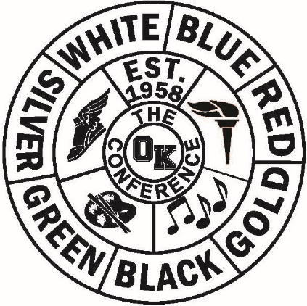

Name/Gr School Name/Gr School
John Rozema | Sparta |  | Dan Kehoe |  | Calvin Christian
Lance Riddle | Sparta |  | Logan Manion |  | Calvin Christian
Jax Wilson | Sparta |  | Ben Wertz |  | Calvin Christian
Logan Seymour | Sparta |  | Luke Vitvliet |  | Calvin Christian
Chris Landry | Sparta |  | Jeremy Ruys |  | Calvin Christian
Jackson Jones | Sparta |  | Landen Klinge |  | Hopkins
Ian Blom | Sparta |  |  | Trevor Shealy | Hopkins
Koden McNeil | Belding |  | Tanner Neuman |  | Hopkins
Dylan Rockburn | Belding |  |  | Luke Sweeney | NorthPointe C.
Kyle Prosser | Belding |  |  | Joel Rodgers | NorthPointe C
Reed Willmore | Belding |  |  | Ethan McConnon | NorthPointe C
TJ Johnson | Belding
Logan Balis | Belding
David Thollander | Belding
Ethan Rockburn | Belding
Cameron Townsend | Kelloggsville
David Smith | Comstock Park
Carter VanderMeer | Comstock Park

OK Conference All-Conference

Sport ______Boys Track

Division ____Silver_________

School Year _____2020-21

AD Name ____Joel Wilker_______

Dual Season Final Standings
School Record Pts School Place Pts
Sparta | 8-0 | 9 |  | Sparta | 1 | 18
Belding | 7-1 | 8 |  | Belding | 2 | 16
Calvin Christian | 6-2 | 7 |  | Calvin Christian | 3 | 14
Hopkins | 5-3 | 6 |  | Hopkins | 4 | 12
Comstock Park | 3-5 | 4 |  | NorthPointe Christian | 5 | 9
NorthPointe | 3-5 | 4 |  | Comstock Park | 6 | 8
Kelloggsville | 3-5 | 4 |  | Kelloggsville | 7 | 7
Godwin | 0-7 | 1.5 |  | Lee | 8 | 3.5
Lee | 0-5 | 1.5 |  | Godwin | 9 | 2.5

Conference Finals Results
School Place Pts
Sparta | 1 | 9
Belding | 2 | 8
Calvin Christian | 3 | 7
Hopkins | 4 | 6
NorthPointe Christian | 5 | 5
Comstock Park | 6 | 4
Kelloggsville | 7 | 3
Lee | 8 | 2
Godwin | 9 | 1

