OK Conference All-Conference  Sport: Volleyball  Division: OK Silver  School Year: 2020/2021  AD Name: Adam Valk (Hopkins) | 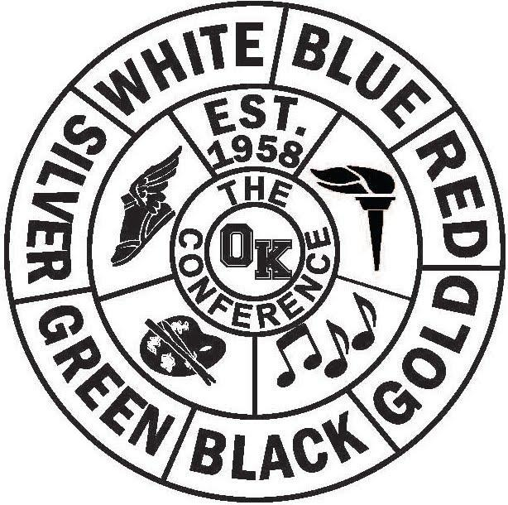

All Conference Team | Honorable Mention Team

Name/Gr School Name/Gr School
Camilla Casado | Kelloggsville |  | Madison Vance | Belding
Mackenzie Heaton | Belding |  | Tori Kik | NPC
Faith Berends | NPC |  | Lilli Pattillo | Comstock Park
Grace Blickley | NPC |  | Avery Roxbury | Hopkins
Alyssa Katerberg | NPC |  | Mady Weber | Hopkins
Emily Heintzelman | Comstock Park |  | Britten Busen | Sparta
Shan’thony Taylor | Comstock Park |  | Reagan Huttenga | Calvin Christian
Anika Clark | Godwin |  | Abbie Groendyke | Lee
Brianna Miller | Hopkins
Corrie Wisser | Hopkins
Lindsay Bulich | Hopkins
Kensey Armock | Sparta
Brooklyn Verbeek | Calvin Christian
Anika Verbeek | Calvin Christian
Morgan Velting | Calvin Christian
Ellie Kosiara | Calvin Christian

OK Conference All-Conference

Sport: Volleyball

Division: OK Silver

School Year: 2020/2021

AD Name: Adam Valk (Hopkins)

Regular Season Final Standings
School Record Pts. School Place Pts
Calvin Christian | 8-0 | 9 |  | Calvin Christian | 1st | 18
Hopkins | 7-1 | 8 |  | Hopkins | 1st | 18
NPC | 6-2 | 7 |  | NPC | 3rd | 15
Comstock Park | 4-3 | 6 |  | Comstock Park | 4th | 12
Belding | 4-4 | 5 |  | Godwin | 5th | 9
Godwin | 3-5 | 4 |  | Belding | 5th | 9
Sparta | 1-6 | 2.5 |  | Sparta | 7th | 5.5
Kelloggsville | 1-6 | 2.5 |  | Kelloggsville | 8th | 4.5
Lee | 0-7 | 1 |  | Lee | 9th | 2

Conference Tournament
School Place Pts.
Hopkins | 1st | 9
Calvin Christian | 2nd | 8
NPC | 3rd | 7
Comstock Park | 4th | 6
Godwin | 5th | 5
Belding | 6th | 4
Sparta | 7th | 3
Kelloggsville | 8th | 2
Lee | 9th | 1

