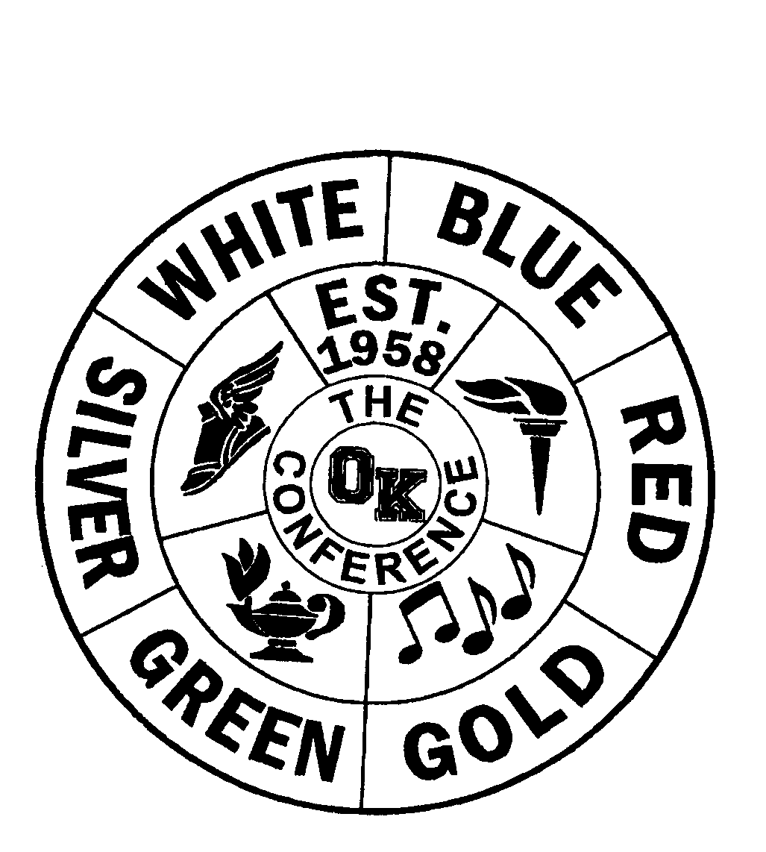
Name/Gr School Name/Gr School
OK Conference All-Conference

Sport __Girls Track and Field________

Division __Red____________________

School Year _2023-24______________

AD Name __Blaine Brumels__________
Alana Bailey | East Kentwood |  | Daisy Cox |  | Rockford
Alana Bracey | East Kentwood |  | Hailey Hill |  | Rockford
Aries Branch | East Kentwood |  | Olivia Hosford |  | Rockford
Arianna Carter | East Kentwood |  | Macy Vanderhout |  | Rockford
Journey Cottle | East Kentwood |  | Addie Birkholz |  | West Ottawa
Kayla Harris | East Kentwood |  | Emma Gunnett |  | West Ottawa
Lexi Hurst | East Kentwood |  |  | Ava Porras | West Ottawa
Ava Lawrence | East Kentwood |  | Helen Sachs |  | West Ottawa
Logan Richardson | East Kentwood |  | Allinna Teav |  | West Ottawa
Abbie Terry | East Kentwood |  |  | Collette Wierks | West Ottawa
Adeline Bagnall | Grand Haven |  |  | Ella Wierks | West Ottawa
Valerie Beeck | Grand Haven
Nadia Preditis | Grand Haven
Addy Smtih | Grand Haven
Eden Smith | Grand Haven
Leigha Stoepker | Jenison
Greta Caprathe | Rockford
Maiya Corrigan | Rockford

OK Conference Final Standings

Sport _Girls Track and Field_________

Division __Red____________________

School Year __2023-24_____________

AD Name __Blaine Brumels_________

Dual Season Conference Meet

School Record Place School Score Place
East Kentwood | 5-0 | 1 |  | East Kentwood | 192 | 1
Rockford | 4-1 | 2 |  | Rockford | 153 | 2
Hudsonville | 3-2 | 3 |  | West Ottawa | 105 | 3
West Ottawa | 3-2 | 3 |  | Grand Haven | 101 | 4
Caledonia | 2-3 | 5 |  | Jenison | 41 | 5
Grand Haven | 2-3 | 5 |  | Hudsonville | 36 | 6
Jenison | 1-4 | 7 |  | Caledonia | 19 | 7
Grandville | 0-5 | 8 |  | Grandville | 14 | 8

Finals Standings
School Place School Record Place Pts
East Kentwood |  | 1
Rockford |  | 2
West Ottawa |  | 3
Grand Haven |  | 4
Hudsonville |  | 4
Jenison |  | 6
Caledonia |  | 7
Grandville |  | 8

